Week 1 (April 1 – April 8, 2022) Wear Blue Day/Individual Week/Week of the Young Child
Friday, April 1 | Facebook  Instagram  LinkedIn | Share our content on your feeds or create your own Child Abuse Prevention Month kick-off post using the asset included in this row. | Post  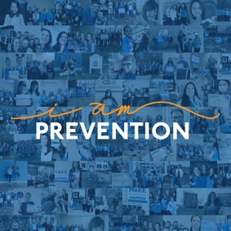
Saturday, April 2  8 a.m. | Facebook  Instagram  LinkedIn | Are you ready New Hampshire? Today is the start of the Week of the Young Child – 2022! How can you join the celebration?  - Post a video of yourself on social media explaining why you celebrate #WOYC22! And what you do to prepare!  - Plan an event with your friends via social media!  - Re-energize so you are ready for what’s to come!  - Visit [INSERT YOUR URL HERE].  .  .  .  #StrongFamilies #JoyfulMoments #Joy #CelebrateFamilies #BePrevention #IAmPrevention #PreventChildAbuse #CAPM2022 | Post  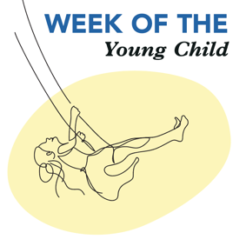
Monday, April 4 | Facebook  Instagram  LinkedIn | Share the Moments of Joy video from NHCT’s feeds! Add your own URL to direct users to your prevention resources.
Tuesday, April 5  Post 1 @ 8 a.m.  Post 2 @ 12 p.m. | Facebook  LinkedIn | Post 1:  Stimulating your children’s minds by showing love and affection when they are young helps build a healthy, balanced young person equipped to meet life’s challenges. It’s part of the “serve and return” relationship that builds brain architecture.  And here are some great ways to do it: https://www.health.harvard.edu/blog/cultivating-joy-as-a-family-2020100921124  .  .  .  #StrongFamilies, #JoyfulMoments, #Joy #CelebrateFamilies #BePrevention #IAmPrevention #PreventChildAbuse #CAPM2022 #Celebratefamilies  Post 2:  TUNE IN via ZOOM: You are Prevention: The Role of Relationships - Thursday, April 14, from 6-7:30 p.m. http://ow.ly/wFR550IrIIe  Relationships build communities, but what goes into building strong relationships? Join us for an engaging discussion about the power of relationships in building community. Facilitated by Michele Holt-Shannon, Director of NH Listens, we’ll listen to members of successful community engagement programs discuss how authentic collaboration and deep listening have impacted their communities, the lives of families, and their access to resources. This will be a 60-minute program with 30 minutes of Q&A at the end.  REGISTER TODAY at the link above! | Post 1  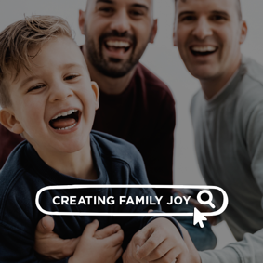  Post 2a  Post 2b  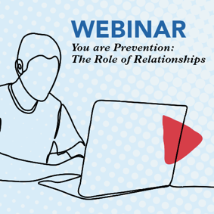  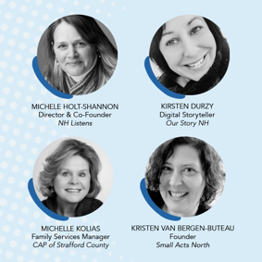
Wednesday, April 6  8 a.m. | Facebook  Instagram  LinkedIn | While our children learn by watching us, “Moments of Joy” are just as important to parents and caregivers. They keep us resilient. [INSERT YOUR URL HERE]  And thankfully, they can be made!  CALL TO ACTION: Take a moment to make a moment of joy in your life! Let us know what it was in the comments below!  For more ways to create moments of family joy, visit the link above.  .  .  .  #StrongFamilies, #JoyfulMoments, #Joy #CelebrateFamilies #BePrevention #IAmPrevention #PreventChildAbuse #CAPM2022 | Post  
Thursday, April 7  Post 1 @ 8 a.m.  Post 2 @ 12 p.m. | Facebook  LinkedIn | Post 1:  Do you know why it is important to hug your child for at least six seconds? Because you are building brain architecture. Holding a hug for that period releases the oxytocin and serotonin, chemical messengers in the brain that aid in bonding and make people feel good.  For a closer look, check out this video! https://www.youtube.com/watch?v=VoN-Gbmn7ws  .  .  .  #StrongFamilies, #JoyfulMoments, #Joy, #CelebrateFamilies #BePrevention #IAmPrevention #PreventChildAbuse #CAPM2022 #MomentsofJoy #Momlife #Dadlife #Moms #Dads #ParentingTips #BuildingResilience  Post 2:  TUNE IN via ZOOM: You are Prevention: The Role of Relationships - Thursday, April 14, from 6-7:30 p.m. http://ow.ly/wFR550IrIIe  Relationships build communities, but what goes into building strong relationships? Join us for an engaging discussion about the power of relationships in building community. Facilitated by Michele Holt-Shannon, Director of NH Listens, we’ll listen to members of successful community engagement programs discuss how authentic collaboration and deep listening have impacted their communities, the lives of families, and their access to resources. This will be a 60-minute program with 30 minutes of Q&A at the end.  REGISTER TODAY at the link above! | Post 1  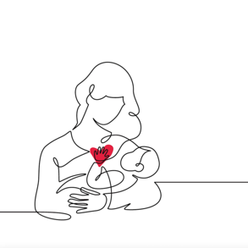  Post 2a  Post 2b
Week 2 (April 11 – 15, 2022) Relationship Week
Monday, April 11  12 p.m. | Facebook  Instagram  LinkedIn | TUNE IN via ZOOM: You are Prevention: The Role of Relationships - Thursday, April 14, from 6-7:30 p.m. http://ow.ly/wFR550IrIIe  Relationships build communities, but what goes into building strong relationships? Join us for an engaging discussion about the power of relationships in building community. Facilitated by Michele Holt-Shannon, Director of NH Listens, we’ll listen to members of successful community engagement programs discuss how authentic collaboration and deep listening have impacted their communities, the lives of families, and their access to resources. This will be a 60-minute program with 30 minutes of Q&A at the end.  REGISTER TODAY at the link above! | Post 1a  Post 1b
Tuesday, April 12  8 a.m. | Facebook  Instagram  LinkedIn | Relationships are at the center of all healthy families. And yet, the joy and affection of every family is unique. [INSERT YOUR URL HERE]  Connecting with other community members helps spread not only family joy but also caregiving strategies, resources, and support, and builds family resilience.  So connect today! Both your family and theirs can grow stronger together.  Visit the link above to learn more and share!  .  .  .  #strongfamilies #momlife #fatherhood #dad #mom #parenting #parentalresources #preventchildabuse #BePrevention #IAmPrevention #PreventChildAbuse #CAPM2022 | Post  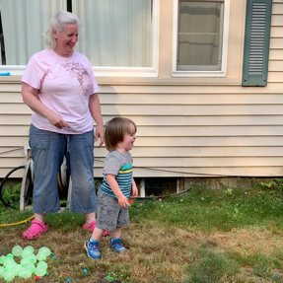
Wednesday, April 13  Post 1 @ 8 a.m.  Post 2 @ 12 p.m. | Facebook  Instagram  LinkedIn | Post 1:  TUNE IN via ZOOM: You are Prevention: The Role of Relationships - Thursday, April 14, from 6-7:30 p.m. http://ow.ly/wFR550IrIIe  Facilitated by Michele Holt-Shannon, Director & Co-Founder of New Hampshire Listens.  Featuring:  - Michelle Kolias, Family Services Manager at the Community Action Partnership of Strafford County  - Kirsten Durzy, Digital Storyteller, Our Story NH  - and Kristen van Bergen-Buteau of Small Acts North  Visit the link above to register!  .  .  .  #strongfamilies #momlife #fatherhood #dad #mom #parenting #parentalresources #preventchildabuse #BePrevention #IAmPrevention #PreventChildAbuse #CAPM2022  Post 2:  NEW on the PODCAST! www.nhchildrenstrust.org/nhfn  Co-Host Nathan Fink welcomes the amazing Lilly Nettensheim, 9-year-old singer, writer, and her father Joel to discuss Lilly’s song “Believe.” And later Loretta Brady, Professor of Psychology at Saint Anselm College, discuss individual and community resilience, and how together we can create more equitable environments through relationships.  LISTEN on Spotify, Apple, or wherever you get your podcasts, or ask your smart speaker to play NH Family NOW!  .  .  .  #podcast #media #interview #podcasting #newepisode #news #strengtheningfamilies #strongfamilies #newhampshire #family #families #parenting | Post 1a  Post 1b  Post 2  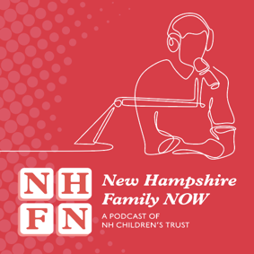
Thursday, April 14  Facebook/LinkedIn: 8 a.m. and 3 p.m.  Instagram: 8 a.m. | Facebook  LinkedIn  Instagram | TONIGHT: from 6 to 7:30 p.m.!  You are Prevention: The Role of Relationships  Facilitated by Michele Holt-Shannon, Director & Co-Founder of New Hampshire Listens. http://ow.ly/wFR550IrIIe  Featuring:  - Michelle Kolias, Family Services Manager at the Community Action Partnership of Strafford County  - Kirsten Durzy, Digital Storyteller, Our Story NH  - and Kristen van Bergen-Buteau of Small Acts North  Visit the link above to register!  .  .  .  #strongfamilies #momlife #fatherhood #dad #mom #parenting #parentalresources #preventchildabuse #BePrevention #IAmPrevention #PreventChildAbuse #CAPM2022 | Post 1a  Post 1b
Friday, April 15  Post 1 @ 8 a.m.  Post 2 @ 12 p.m. | Facebook  Instagram  LinkedIn | Post 1:  All caregivers need support sometimes. It can be as simple as calling a friend to see how they are. Or it could be dropping off a meal for a neighbor. [INSERT YOUR URL HERE]  CALL TO ACTION: Call a family member, friend or neighbor and offer to make a meal or watch their child.  Knowing others are there for you helps build resilience. Discover your resilience factor at the link above.  .  .  .  #strongfamilies #momlife #fatherhood #dad #mom #parenting #parentalresources #preventchildabuse #BePrevention #IAmPrevention #PreventChildAbuse #CAPM2022  Post 2:  TUNE IN via ZOOM: We are Prevention: Engaging Community at All Levels – Thursday, April 21, from 12-1:30 p.m. http://ow.ly/Bgku50IrJm3  Join us for this energizing conversation anchored in building systems across sectors that strengthen families and promote safe, stable, and nurturing environments for children. Together, the panel will share their stories, what is working, and how to bring that success to other communities across the state. This will be a 60-minute panel discussion with 30 minutes of Q&A at the end.  REGISTER TODAY at the link above! | Post 1  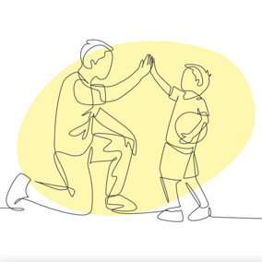  Post 2a  Post 2b  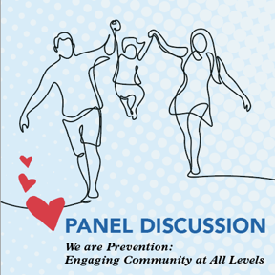  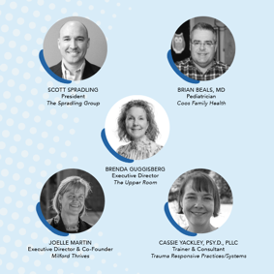
Week 3 (April 18 – 22, 2022) Community Week
Tuesday, April 19  8 a.m.  Post 1 @ 8 a.m.  Post 2 @ 12 p.m. | Facebook  Instagram  LinkedIn | Post 1:  Identifying and understanding developmental milestones can be challenging for anyone. After all, your child is a unique as you are.  Connection to Family Resource Centers and other community resources can help families pinpoint family strengths and find parenting strategies that fit.  Everyone plays a role in building family well-being. Connect with your local Family Resource Center today at www.fsnh.org  .  .  .  #strongfamilies #momlife #fatherhood #dad #mom #parenting #parentalresources #preventchildabuse #BePrevention #IAmPrevention #PreventChildAbuse #CAPM2022 #grandparents #grandmothers #grandfathers  Post 2:  TUNE IN via ZOOM: Be Prevention: Advocating for a Stronger NH – Tuesday, April 26, from 12-1:30 p.m. http://ow.ly/j5zJ50IrJFz  Have you ever wondered how to make your voice heard when it matters? New Futures is the lead nonpartisan organization in the state that advocates, educates, and collaborates to improve the health and wellness of all Granite State residents through policy change. Come and learn how your stories matter and their impact on legislative decisions. This is a 60-minute program with 30 minutes of Q&A at the end. @NewFutures  REGISTER TODAY at the link above! | Post 1  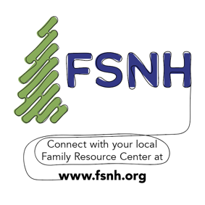  Post 2a  Post 2b  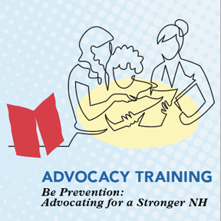  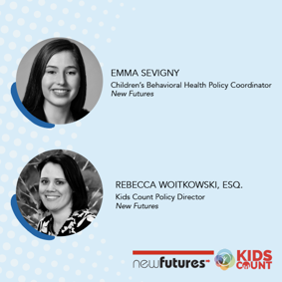
Wednesday, April 20  Post 1 @ 8 a.m.  Post 2 @ 12 p.m. | Facebook  Instagram  LinkedIn | Post 1:  The Children’s Trust Fund Alliance (CTFA) recommends the creation of youth advisory boards and/or councils that can engage young people in examining programs, practices and policies that affect their lives.  Why? Because youth are an essential part of our communities and can help lead positive changes through advocacy.  What are some other ways you think human service agencies can better engage youths?  Please share your thoughts in the comments section below!  .  .  .  #strongfamilies #momlife #fatherhood #dad #mom #parenting #parentalresources #preventchildabuse #BePrevention #IAmPrevention #PreventChildAbuse #CAPM2022 #grandparents #grandmothers #grandfathers  Post 2:  TUNE IN via ZOOM: We are Prevention: Engaging Community at All Levels – Thursday, April 21, from 12-1:30 p.m. http://ow.ly/Bgku50IrJm3  Join us for this energizing conversation anchored in building systems across sectors that strengthen families and promote safe, stable, and nurturing environments for children. Together, the panel will share their stories, what is working, and how to bring that success to other communities across the state. This will be a 60-minute panel discussion with 30 minutes of Q&A at the end.  REGISTER TODAY at the link above! | Post 1  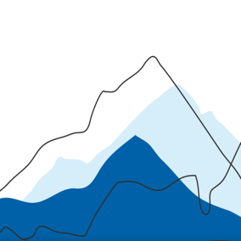  Post 2a  Post 2b
Thursday, April 21  8 a.m. | Facebook  Instagram  LinkedIn | TODAY: from noon to 1:45 p.m.!  We are Prevention: Engaging Community at All Levels - Facilitated by Scott Spradling, President of the Spradling Group. http://ow.ly/Bgku50IrJm3  Featuring Brian Beals, MD (Pediatrician), Brenda Guggisberg (Upper Room), Joelle Martin (Milford Thrives), and Dr. Cassie Yackley (Center for Trauma-Responsive Practice Change)  REGISTER TODAY at the link above!  .  .  .  #strongfamilies #momlife #fatherhood #dad #mom #parenting #parentalresources #preventchildabuse #BePrevention #IAmPrevention #PreventChildAbuse #CAPM2022 #grandparents #grandmothers #grandfathers | Post 1a  Post 1b
Friday, April 22  Post 1 @ 8 a.m.  Post 2 @ 12 p.m. | Facebook  LinkedIn | Post 1:  Community awareness of protective factors and how you build them can strengthen not only individuals and families but also the community as a whole.  CALL TO ACTION: take a look at this short video: https://www.youtube.com/watch?v=yXTodqd8WIU abuse and strengthen families  .  .  .  #strongfamilies #momlife #fatherhood #dad #mom #parenting #parentalresources #preventchildabuse #BePrevention #IAmPrevention #PreventChildAbuse #CAPM2022 #grandparents #grandmothers #grandfathers  Post 2:  Are a family support and strengthening professional? Engage with the protective factors!  CALL TO ACTION: Download your 2021/2022 Prevention Resource Guide from our national partners TODAY to learn about actions we can all take within communities, organizations, and families to build protective factors in the community.  https://www.childwelfare.gov/topics/preventing/preventionmonth/resources/resource-guide/  .  .  .  #strongfamilies #momlife #fatherhood #dad #mom #parenting #parentalresources #preventchildabuse #BePrevention #IAmPrevention #PreventChildAbuse #CAPM2022 #grandparents #grandmothers #grandfathers | Post 1  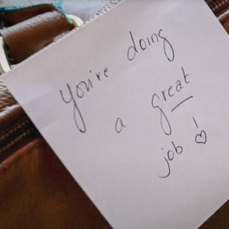  Post 2  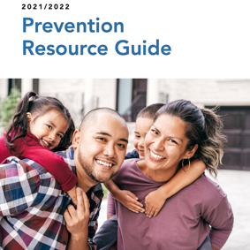
Week 4 (April 25 – April 29, 2022) Society Week
Monday, April 25  Post 1 @ 8 a.m.  Post 2 @ 12 p.m. | Facebook  Instagram  LinkedIn | Post 1:  By focusing attention on the diverse cultural interests of families, providers strengthen authentic partnerships with parents and children. [INSERT YOUR URL HERE]  Identifying and addressing each families unique challenges also strengthens the community and society as a whole.  For more tips on engaging families, visit the link above.  .  .  .  #strongfamilies #momlife #fatherhood #dad #mom #parenting #parentalresources #preventchildabuse #BePrevention #IAmPrevention #PreventChildAbuse #CAPM2022 #grandparents #grandmothers #grandfathers  Post 2:  TUNE IN via ZOOM: Be Prevention: Advocating for a Stronger NH – Tuesday, April 26, from 12-1:30 p.m. http://ow.ly/j5zJ50IrJFz  Have you ever wondered how to make your voice heard when it matters? New Futures is the lead nonpartisan organization in the state that advocates, educates, and collaborates to improve the health and wellness of all Granite State residents through policy change. Come and learn how your stories matter and their impact on legislative decisions. This is a 60-minute program with 30 minutes of Q&A at the end. @NewFutures  REGISTER TODAY at the link above! | Post 1  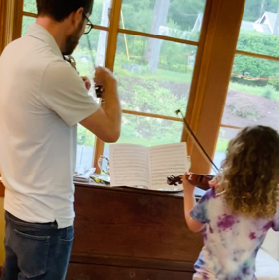  Post 2a  Post 2b
Tuesday, April 26  8 a.m. | Facebook  Instagram  LinkedIn | TODAY: from noon to 1:30 p.m.! http://ow.ly/j5zJ50IrJFz  Be Prevention: Advocating for a Stronger NH -  Presented by New Futures - Emma Sevigny, Children's Behavioral Health Policy Coordinator & Rebecca Woitkowski, Esq., Kids Count Policy Director  Visit the link above to register!  .  .  .  #strongfamilies #momlife #fatherhood #dad #mom #parenting #parentalresources #preventchildabuse #BePrevention #IAmPrevention #PreventChildAbuse #CAPM2022 #grandparents #grandmothers #grandfathers | Post 1a  Post 1b
Wednesday, April 27  12 p.m. | Facebook  Instagram  LinkedIn | NEW on the PODCAST! www.nhchildrenstrust.org/nhfn  Co-Hosts Joelyn Drennan and Nathan Fink welcome Dr. Melissa Merrick, President and CEO of Prevent Child Abuse America (PCAA), to discuss our nations commitment to the well-being of children and families. And later NH State Senator Rebecca Whitley joins us to discuss Granite State legislative efforts to make for more family-friendly policies.  LISTEN on Spotify, Apple, or wherever you get your podcasts, or ask your smart speaker to play NH Family NOW!  .  .  .  #podcast #media #interview #podcasting #newepisode #news #strengtheningfamilies | Post
Thursday, April 28  8 a.m. | Facebook  LinkedIn | How can community-based family support agencies in New Hampshire and other family serving professionals be mindful of local, state, and federal policies that affect children?  By understanding which policies positively impact the lives of children and families.  The three levels of policy to consider are:  - Legislative: Laws and ordinances passed by local, state, and federal governmental entities.  - Regulatory: Methods established by governmental agencies that have regulatory authority for products and services.  - Organizational: Rules and practices an organization sets for conducting business. https://www.childwelfare.gov/pubPDFs/guide_2021.pdf  .  .  .  #strongfamilies #momlife #fatherhood #dad #mom #parenting #parentalresources #preventchildabuse #BePrevention, #IAmPrevention, #PreventChildAbuse #CAPM2022 #grandparents #grandmothers #grandfathers | Post  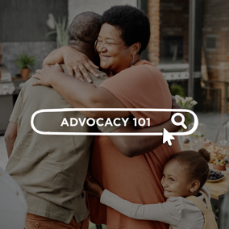
Saturday, April 30  8 a.m. |  | Thank YOU for participating in this year's Child Abuse Prevention Month, and every day, to help families and children thrive. [INSERT YOUR URL HERE]  While we highlight this important work in April, PREVENTION is a year-round effort that requires cross-sector collaboration, meaningful conversation, and awareness efforts.  But the result is simple: supportive communities = stronger families. So thank you—your support makes PREVENTION possible.  I am prevention. YOU are prevention. WE are prevention. Continue this journey with us at the link above.  .  .  .  #strongfamilies #momlife #fatherhood #dad #mom #parenting #parentalresources #preventchildabuse #BePrevention #IAmPrevention #PreventChildAbuse #CAPM2022 #grandparents #grandmothers #grandfathers | Post  